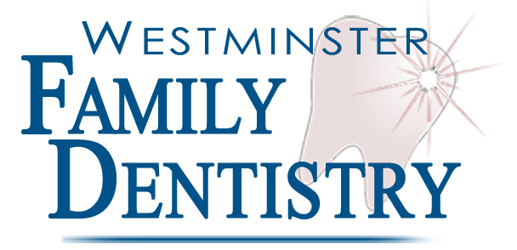
Dr. Anne Etzkorn, DDS
Cosmetic and General Dentistry

Directions to Our Office
From: Eldersburg/Sykesville, MD (Time: 28 minutes)
To: Westminster Family Dentistry, LLC
115 Airport Drive, Suite 110
Westminster, MD 21157

- Take 97N towards Westminster for 10 miles
- Turn Left onto 97N/140W to stay on 97N for about 2.2 miles
- Take the ramp and Merge onto 97N for about 1 mile
- Turn Left at the light onto Airport Drive (near the local airport)
- Take your first left into the Air Business Park and drive around the front of the Social Security building.
- Continue straight until you see our office sign (Suite 110) (directly across from the Jiffy Mart)

We will see you soon!

Call us at 443-244-9222 if you have any problems getting here

